Borrowed Time Films
HELLBLADE
Mock Review
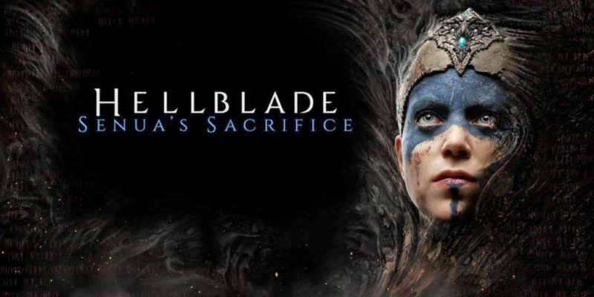
mrhowdesigns@gmail.com
7/2/2020

*the game was not played in vr so I have no sort to comment on its implementation
*full respect and credit to the developers of the game and the effort they have put in.

Hellblade is a well crafted and uniquely designed product that earns a well deserved place in any gamer’s library. It is also most certainly deserving of its many accolades – in particular the Bafta sound design award. Once in a while titles challenge the credo – “are video games art?” and Hellblade is treading close. Does it get over the mark though? Let’s find out.
From the get go you’ll see little to no HUD elements during Hellblade. Clearly one of the many bold design choices the puts priority on a cinematic gaming experience. This is coupled with an incredible auditory experience. You are recommended from the get go to use your headphones with good reason. The audio does quite a bit of heavy lifting for the UI elements.
The narrative begins by leaving the viewer asking a lot of questions and being driven into the game world to find them. It’s clear that your character - Senua is quite mad, or you might just be another voice inside Senua’s head; swirling endlessly around her brain and along for the chaotic ride. It’s clear Senua has suffered great trauma and this has created psychosis. It’s also clear the game has taken care in this topic and researched it thoroughly. The studio sort to work directly with experienced doctors and psychologists in the field. The game also does warn gamers/viewers of what lies ahead when they pick up the game. It is an ultraviolent and intense experience that is not for the faint of heart.
The game plays out with cinematic craftsmanship that even the likes of Last of Us should be envious of. The camera never cuts and the sequences and animations of the game transition smoothly from player camera to story every time. Often this is done with a clever mix of overlayed video of other characters speaking to Senua and enhancing the film feeling further. The dark transitions and swirly camera cleverly mask level load changes or transitions to new areas.
The setting is honestly remarkable and well delivered on by the environment team. The locations feel authentic and foreboding to move through. You have good landmarks to come back to and usually having a strong gameplay theme in each area that is tied well to the environment. It reminded me of classics like Journey or Shadow of the Colossus.
The combat mechanics - when combat does occur - are executed on rather faultlessly in true Ninja Theory Style. You intuitively flow into the combat state and often take your queues from the audio or telegraphed animations. The fights are frantic and desperate; with players always feeling like they are on a knife edge and one step from deaths door. The controls are simple and elegant and the combos and killing blows are tied to a nice flow of parrying/heavy/light attacks or melees. Each enemy is susceptible to most attacks; it would have been good to require some hard counters to move past certain threats.
The difficulty system has received some polarising opinions from day one because the game warns players early on that if Senua should succumb to the darkness (rot inside her) - the journey will end. This could have been a bold design decision. It brings more meaning to each of the combat sections (even if you later discover it to be a bluff). However, the rot isn’t implemented as you would expect to where you can die – creeping forward keeping you on edge. It will only truly creep forward at key narrative moments. I’d have been interested in the system being permanent - particularly if you went in on a new game plus variant.
Players have the power to reduce the difficulty should the need arise if they are/were worried they may not complete the story due to the implied perma-death. The options for difficulty are labelled well but the easier difficulties lesson the experience and I feel players will enjoy the experience more on Auto or Normal + difficulty. I left the difficulty on Auto for the most part, with an interest in how this might modify the experience. After multiple deaths in one of the games more confusing sections where you run from an invincible enemy towards light – I came to realise the mechanic was not actually there, merely a bluff from the developers to increase the tension and emulate some forms of mental illness. I had changed the difficulty to easy for fear I’d lose progress. But in the process I also reduced the joy in each combat section as the challenges became more remedial. Given their time again, maybe ninja should have given the player more chances to feel smart here and discover it wasn’t real early on – or – allow a custom difficulty where perma-death can be disabled, but heavily reward those who do complete the game with it active.
Generally I didn’t feel particularly well setup for combat by the game. It offers no onboarding or tutorial and those unfamiliar with souls like combat which is heavily reliant on observation and reaction to animations; may struggle early on. Audio queues are you biggest saviour here. Listening for them will aid you greatly in combat.
The boundaries of the world and the way forward can be a little unclear at times. I felt like the game needed to buffer the height metrics a little more. Quite often I’d be met with a ledge in easy reaching distance and on the way forward but be unable to interact with it because it was not deemed climbable. These unclear boundaries lead to a few incidences of frustrating navigation and a bit of back tracking.
The level design for the most part flows well and you often seem to end up in the right place. The level design puzzles are usually quite intuitive and the designers haven’t made any mechanics a one and done. Often a trick of the trade must be mastered and players challenged to do more. This is usually coupled with some incredible art visuals and auditory to help signal/lead/ or simply enhance the mood of these distinct gameplay areas. Quite often the game sets up the actions with Hub and spoke areas and these work well to pace and segment the action. Once an area is complete, the player is then guided back to the start area well with light, new doors and key land marks. This removes the need to try to back track through any labyrinths you just completed, keeping the player on the journey and in the hot seat. The hub layouts also help with this.
I’d have liked to have seen the environments react a little more to the mood or emotions of the character. They are well constructed but don’t often surprise the player. An occasional rickety bridge collapse – or more care to an expanding and contracting world could have helped here - dropping the edge of the world away for the occasional vista where the mood matched. Players may feel a bit hemmed in which can lead to a more corridorish’ experience in earlier levels. This improved over time and the variety extended greatly, providing some truly memorable and dramatic moments, particularly dynamic elements that morphed or formed in front of the player, harking back to the Dishonored 2 clockwork mansion. It would have been nice to have the spread better throughout all levels.
I would have been open to more abilities for Senua. She is a brutal tough Celtic woman but often feels under equipped for the world – stopped by a small boulder or unable to ledge pull up onto a nearby surface. I’d have liked the world metrics to be a little more generous here and reduce the friction and clutter in aid of a clearer and cleaner navigation experience. Buffering metrics in the interest of a clearer and more readable world cannot be understated enough. Using shape theory more robustly would have also helped the developers create a more readable world.
The combat became a touch repetitive by the end. Originally the enemies felt thematically well linked to each environment but by the end the developers simply increase in amount and run out of variation. This was kind of expected with a title in this price range. It would have been great to put more thought into how each enemy synergises with others, so that combinations could be made to better challenge the player. Also investigate how the environment could affect certain enemies. Very few enemies used ranged attacks to force a simple roll to evade or allow better encounter staging and “combat puzzles”. I’d also have liked more agency in combat. The parries are satisfying and the focus build up keeps the combat flow, but it does still fatigue by the end –somewhat detracting from the experience. Have some ranged only foes or requiring different actions from the player to overcome the enemies could have reduced the button mash.
The bosses are memorable and each is truly gorgeously detailed from a character design pov. But the strategy to beat each never evolved in a meaningful way – they simply required cleaner parries and dodges from the player. I was forced to get faster but never change strategies.
The true Hero of the game comes in the form of Unreals new technology that allowed the developers to capture facial animations and the performance in real time. The actors have been chosen/directed extremely well. The performance of the main actress is truly startling. It raises the title amongst the cinematic gods of the likes of Last of Us - God of War or the sleeper horror hit Until Dawn.
Even if the combat does fall a little short and it can be a touch frustrating at times - It’s a must play title for me. It’s held back by a few short comings with the variety of the overall experience, but an essential title for any gamer looking to see the medium evolve and push the narrative envelope and boundaries between cinema and games.

